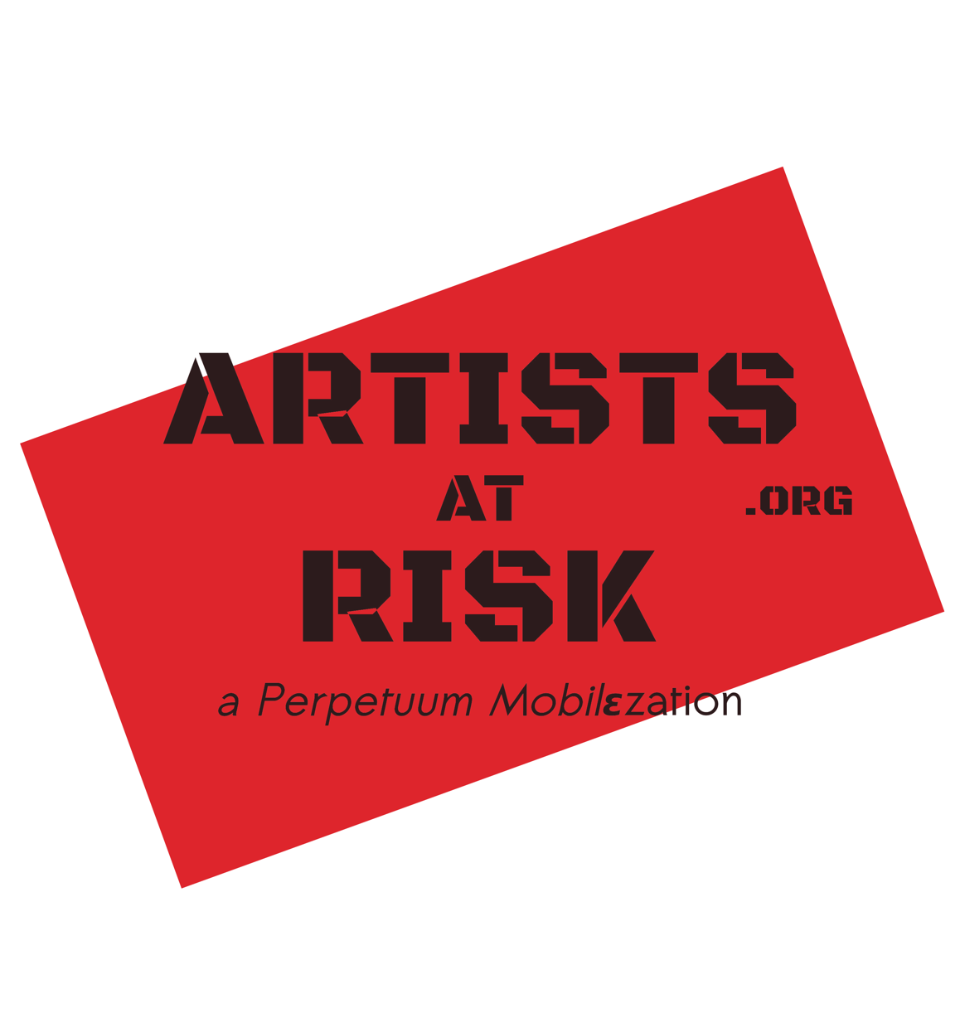

ARTISTS at RISK (AR): Application Form
Please note that all ART PRACTIITIONERS may apply, including curators, critics, theorists, etc.
Please complete and submit your application through this document. It is required that you fill in all mandatory fields (starred *) and attach the required documents.
You can submit your application in all major languages, although we prefer English. All applications must eventually be translated into English for the Jury, which may incur delays and extra costs to AR. If you can, please submit your application in English.

* Indicates a REQUIRED field.

Email address: *

Surname/Family Name: *

First Name/Given Name(s): *

Artist Name (Nom de Plume): *

Profession / Artistic discipline / Practice: *

Gender: *

Citizenship / Nationality: *

Passport / ID: *

Please provide a scan/photo of your passport / ID
Files submitted:

Marital status: *

Children:
Provide names and ages, if applicable. If your children would be travelling with you, please give further details about their needs and educational requirements.

Current Residency Status / Travel Bans: *
Briefly describe your current residency status / right to travel. Are you subject to any official or unofficial travel bans? (Detailed information can be provided in Section 4 below.)

Artistic Practice
Briefly describe your artistic practice:

Links to recent exhibitions, performances, productions, publications, etc.
You can also provide this in your portfolio (next field)

Please provide a portfolio and/or samples of your work: *
(upload a file)
We prefer to receive videos as links to Vimeo / Youtube etc. (add these to the previous field)

Please attach your C.V. *

List any AWARDS and/or major GRANTS
These may relate to your artistic work or human rights activities. Please include dates and names of the award-giving organisations.

PLANS FOR RESIDENCY IF ACCEPTED:
Please attach a separate sheet marked PLANS and describe your plans and expectations for your stay, should you be selected for an Artists-at-Risk residency. For example, what kind of artistic projects would you work on? If you have an academic background, please describe your experience and credentials and indicate your interest in teaching.

Attacks/Threats/Arrest
Please include the following information in your description of the situation

The nature of the attack(s)/threat(s): *
Please clarify dates. Identity of persons carrying out attack/threat. Describe the attack/threats. Describe what you believe is the motivation of your attackers and why you believe this.

Describe what you did after the attack(s) or threat(s):
Please explain what happened as a result of your actions. For example, what, if anything, did the police/authorities do to help? Can or did you appeal through the legal system for protection and/or investigation? If the police is not a reliable organisation in your country, could you turn to other organisations? Did you appeal to humanitarian organization for help?

Additional Reasons for attacks/threats/ill-treatment other than your art:
Additional reasons may include: persecution due to gender, sexual orientation, religious or social group, ethnic minority, perceived political opinion, etc.

Dates and places of arrest (if applicable):
Place of detention and length of time you were detained. Forces who arrested/detained you, or the forces you believe were responsible—and why you believe they were responsible.

Official reason for your arrest (if applicable):
Which authorities issued the arrest warrant or made the decision, and according to which laws/charges/legislation was applied in your case?

Details you may want to include about the circumstances of your arrest or your treatment during the arrest or detainment (if applicable).

Current Situation: *
Please describe your CURRENT SITUATION today. For example, what are the obstacles to living/returning to your country of origin? If you live/return to your country of origin will you or members of your family face detention or danger?

Residence Status / Travel Bans / Visas
Residence status (in your country of origin and in the country of your current residence):

Country of Residence *
If you are living outside your normal country of residence, please give the date of arrival in current country of residence and the date when your permit to stay in the country expires.

History of Residency
Please list all the countries/places in which you have spent substantial time in. If you have left your normal country of residence, please Include the dates of your departure and arrival in other countries/places, your residential status while there, and your reasons for moving.

EU Shengen Visa:
Tick all that apply.
  - Currently Valid Shengen Visa
  - Previously Valid Shengen visas
Relevant EU / other visas that you hold or have held in the past
Please provide the dates

Contact Information:
Mobile Telephone Number(s): *
Please include the country code

Other Telephone Number(s):
Please include the country code

E-mail: *

Social Media Profiles / Website(s)

SECURE COMMUNICATIONS. We recommend you install Wire! *
Artists at Risk (AR) uses WIRE for secure communications in difficult situations. You can register an account using any e-mail address here: https://app.wire.com/. We recommend doing this first, and only later installing the app on your phone. This way, Wire has the advantage of NOT requiring you to use your telephone number, and also NOT sharing your contact list. You can send your Wire name to artistsatrisk@gmail.com at any time. Please list here any services that you have, and how to find you: Wire, Signal, WhatsApp, Telegram, PGP-encrypted e-mail or other.

Languages: *
Please list the languages you are able to speak and the levels of proficiency. For example: Arabic / native, English /Good, Spanish/ Advanced, Kurdish/ Fair.

Institutional Affiliation(s) / Employer(s) (if applicable)
Please give relevant Contact Information (address, telephone, e-mail), Dates Employed, Reasons for Leaving Employment / Affiliation.

May Artists-at-Risk contact this institution for references?
Mark only one oval.
  - Yes
  - No
  - Other:
Employment skills (e.g. teaching, translation, other professional skills):

REFERENCES
Please provide the names and contact information of two persons who can comment on your work as an art practitioner, and on your present circumstances. It should be possible for AR to contact your references by email or telephone. It is advisable to ensure that your referring individuals are willing to be contacted by Artists-at-Risk in confidence.

1st Reference:
Name, Telephone, Email, Postal Address, Does the reference speak English? If not, which language(s) does s/he speak?

Relationship to applicant
For example, is this person a fellow art practitioner, employer, individual or representative of organisation with specialist knowledge of your situation and/or the general state of freedom of expression and other human rights in your country?

2nd Reference:
Name, Telephone, Email, Postal Address, Does the reference speak English? If not, which language(s) does s/he speak?

Relationship to applicant:
For example, is this person a fellow art practitioner, employer, individual or representative of organisation with specialist knowledge of your situation and/or the general state of freedom of expression and other human rights in your country?

Signature
I confirm that the information provided in this application is correct, true and complete. I also confirm that I understand that, should I be approved for candidacy as a Art Practitioner in an AR-Safe Haven, I am not guaranteed a placement within the network. Nevertheless, AR will do the best it can to help you.
Applicant’s signature (photo or scan) *

Please write the following sentence on a piece of paper:
"I confirm that the information provided in this application to Artists at Risk (AR) is correct, true and complete." Write your name underneath, and sign this document. Please upload a photo/scan of this document below.

Date:
Example: 15 December 2012

Future changes in your situation:
If any of the information provided here by the applicant or on behalf of the applicant changes in any way during the processing and waiting period, he or she is required to notify the Artists-at-Risk. Inaccurate information may result in the applicant losing his or her status as an Artists-at-Risk candidate or as an AR-Resident. Please submit all relevant information to AR via e-mail to ARTISTSATRISK@GMAIL.COM or Wire (see "Secure Communications" above).

Signature
If any of the information provided here by the applicant or on behalf of the applicant changes in any way during the processing and waiting period, he or she is required to notify the Artists-at-Risk staff. Inaccurate information may result in the applicant losing his or her status as an Artists-at-Risk candidate or as an AR-Resident.

I confirm that the information provided in this application is correct, true and complete.
I also confirm that I understand that, should I be approved for candidacy as a Art Practitioner in an AR-Safe Haven, I am not guaranteed a placement within the network.

Applicant’s signature:

______________________________________________

Date:

________________

